**Village**

**:**

Baradih

**District**

**:**

Rohtash

**Focus**

**Crops**

**:**

Paddy

,

Groundnut

,

Veg

**Participants**

**Attended**

**By**

**:**

DMM

-

Ashish

Pratap

Singh

**Dealer**

**:**

**Name**

**:**

Dhiraj

enterprises

**Proprietor**

**:**

Dhiraj

dube

**Location**

**:**

Harnachiti

**Mobile**

**:**

62049 18844

**Attendance**

**:**

50+

farmers

**Topics**

**Discussed**

1

.

Company

profile

and

vision

.

2

.

S

2

H

Project

,

services

,

and

products

:

**CPC**

**:**

Azole

Pevota

,

Onvix

,

lexon

-

Etc

**SN**

**:**

Sulton

,

Superrhiza

,

Sulfino

Gold

,

etc

.

3

.

Importance

of

soil

testing

&

Bio

-

Fertilizers

.

4

.

Benefits

of

Superrhiza

in

all

crops

.

5

.

Addressed

farmer

queries

with

solutions

.

6

.

Encouraged

download

of

Uttam

Krishi

Mitra

app

.

7

.

Explained

app

features

and

benefits

for

daily

farming

.

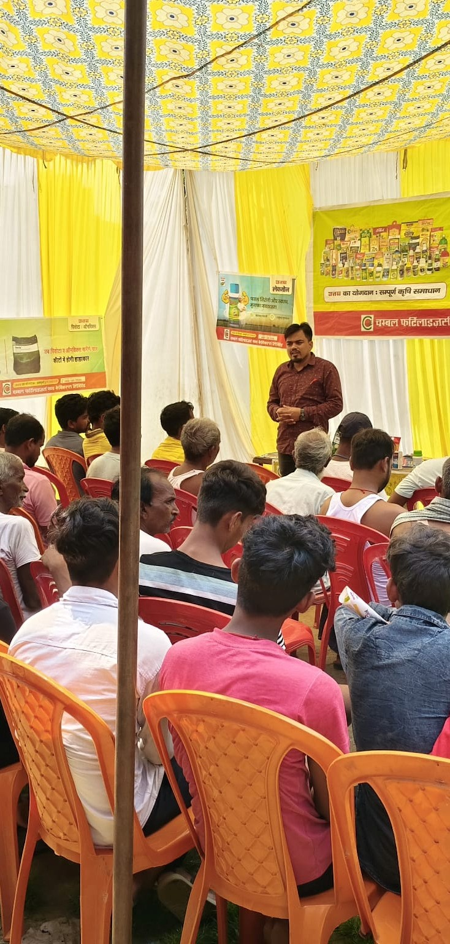

**Meeting**

**Organized**

**By**

**:**

Mr. Arunish kumar, UKS Rohtash

**Village**

**:**

Nawadih

**District**

**:**

Rohtash

**Focus**

**Crops**

**:**

Paddy

**Participants**

**Attended**

**By**

**:**

AMM

-

Ashish

Pratap

Singh

(

Sasaram

)

**Dealer**

**:**

**Name**

**:**

Mayank

khad

bhandar

**Location**

**:**

Nimiyadih

**Mobile**

**:**

9708884201

**Attendance**

**:**

40+

farmers

**Topics**

**Discussed**

1

.

Company

introduction

.

2

.

S

2

H

Project

,

services

,

and

products

:

**CPC**

**:**

Onvix

,

Pevota

,

Azole

,

Metroz

,

etc

.

**SN**

**:**

Sulton

,

Superrhiza

,

Sulfino

Gold

,

etc

.

3

.

Importance

of

soil

testing

&

Bio

-

Fertilizers

.

4

.

Importance

of

Superrhiza

in

Paddy

crops

.

5

.

Addressed

farmer

queries

with

solutions

.

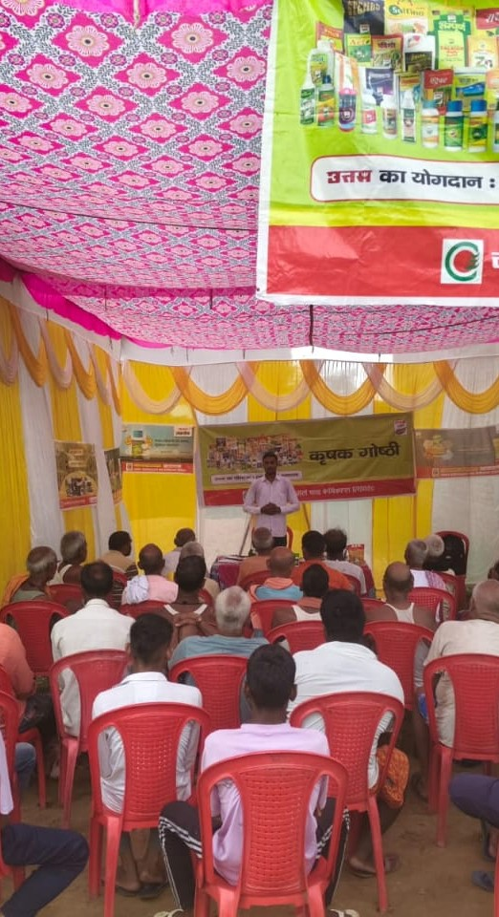

**Meeting**

**Organized**

**By**

**:**

Mr. Arunish kumar, UKS Rohtash

**Village**

**:**

Kushdihra

**District**

**:**

Rohtash

**Focus**

**Crops**

**:**

Paddy

**Participants**

**Attended**

**By**

**:**

AMM

-

Ashish

Pratap

Singh

(

Sasaram

)

**Dealer**

**:**

**Name**

**:**

Priyanshu

khad

bhandar

**Location**

**:**

Nimiyadih

chock

**Mobile**

**:**

8873274362

**Attendance**

**:**

40+

farmers

**Topics**

**Discussed**

1

.

Company

introduction

.

2

.

S

2

H

Project

,

services

,

and

products

:

**CPC**

**:**

Onvix

,

Pevota

,

Azole

,

Metroz

,

etc

.

**SN**

**:**

Sulton

,

Superrhiza

,

Sulfino

Gold

,

etc

.

3

.

Importance

of

soil

testing

&

Bio

-

Fertilizers

.

4

.

Importance

of

Superrhiza

in

Paddy

crops

.

5

.

Addressed

farmer

queries

with

solutions

.

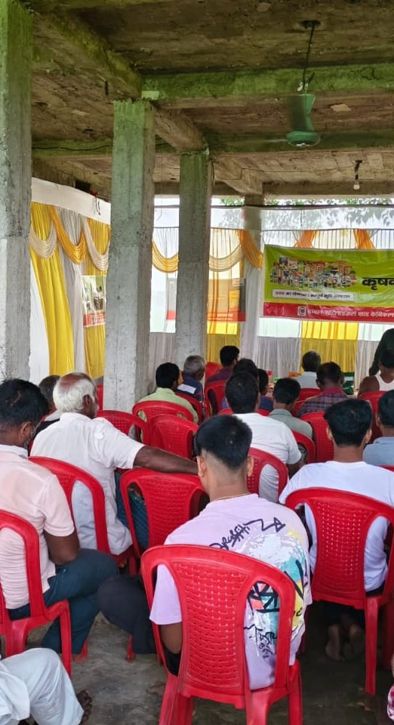

**Meeting**

**Organized**

**By**

**:**

Mr. Arunish kumar, UKS Rohtash

**Village**

**:**

Huruka

**District**

**:**

Rohtash

**Focus**

**Crops**

**:**

Paddy

,

Groundnut

,

Veg

**Participants**

**Attended**

**By**

**:**

DMM

-

Ashish

Pratap

Singh

**Dealer**

**:**

**Name**

**:**

kisan

beej

bhandar

**Proprietor**

**:**

rana

singh

**Location**

**:**

Huruka

**Attendance**

**:**

50+

farmers

**Topics**

**Discussed**

1

.

Company

profile

and

vision

.

.

2

S

2

H

Project

,

services

,

and

products

:

**CPC**

**:**

Azole

Pevota

,

Onvix

,

lexon

-

Etc

**SN**

**:**

Sulton

,

Superrhiza

,

Sulfino

Gold

,

etc

.

3

.

Importance

of

soil

testing

&

Bio

-

Fertilizers

.

4

.

Benefits

of

Superrhiza

in

all

crops

.

5

.

Addressed

farmer

queries

with

solutions

.

.

6

Encouraged

download

of

Uttam

Krishi

Mitra

app

.

7

.

Explained

app

features

and

benefits

for

daily

farming

.

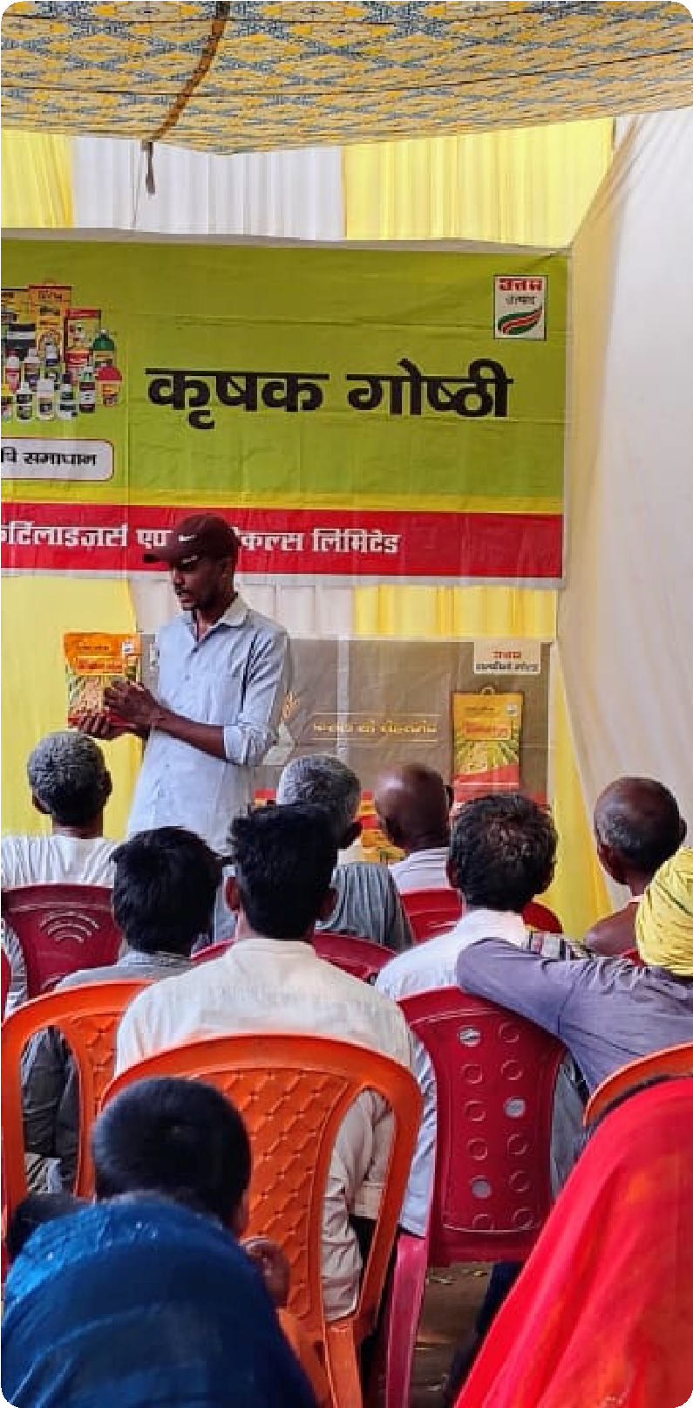

**Meeting**

**Organized**

**By**

**:**

Mr. Arunish kumar, UKS Rohtash

**Village**

**:**

Shahpur

**District**

**:**

Rohtash

**Focus**

**Crops**

**:**

Paddy

**Participants**

**Attended**

**By**

**:**

AMM

-

Ashish

Pratap

Singh

(

Sasaram

)

**Dealer**

**:**

**Name**

**:**

Swastik

enterprises

**Proprietor**

**:**

vishal

singh

**Location**

**:**

India

gate

chenari

**Mobile**

**:**

8084111799

**Attendance**

**:**

50+

farmers

**Topics**

**Discussed**

1

.

Company

introduction

.

.

2

S

2

H

Project

,

services

,

and

products

:

**CPC**

**:**

Onvix

,

Pevota

,

Azole

,

Metroz

,

etc

.

**SN**

**:**

Sulton

,

Superrhiza

,

Sulfino

Gold

,

etc

.

.

3

Importance

of

soil

testing

&

Bio

-

Fertilizers

.

4

.

Importance

of

Superrhiza

in

Paddy

crops

.

5

.

Addressed

farmer

queries

with

solutions

.

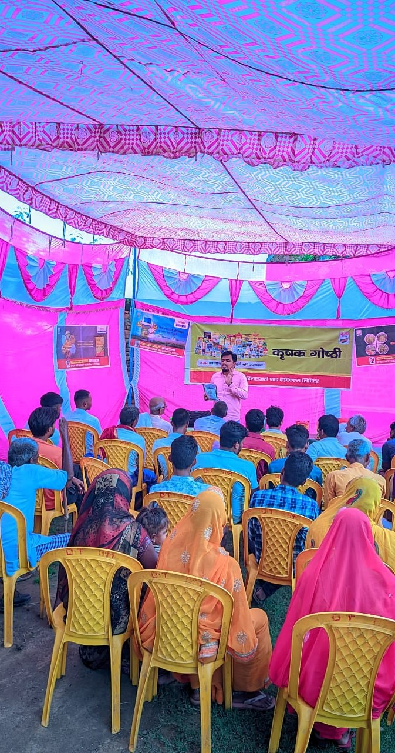

**Meeting**

**Organized**

**By**

**:**

Mr. Arunish kumar, UKS Rohtash

**Village**

**:**

Rendia

**District**

**:**

Rohtash

**Focus**

**Crops**

**:**

Paddy

**Participants**

**Attended**

**By**

**:**

AMM

-

Ashish

Pratap

Singh

(

Sasaram

)

**Dealer**

**:**

**Name**

**:**

Sukrit

ksss

**Proprietor**

**:**

Chandan

Singh

**Location**

**:**

rendia

gate

chenari

**Mobile**

**:**

9572008571

**Attendance**

**:**

40+

farmers

**Topics**

**Discussed**

1

.

Company

introduction

.

.

2

S

2

H

Project

,

services

,

and

products

:

**CPC**

**:**

Onvix

,

Pevota

,

Azole

,

Metroz

,

etc

.

**SN**

**:**

Sulton

,

Superrhiza

,

Sulfino

Gold

,

etc

.

.

3

Importance

of

soil

testing

&

Bio

-

Fertilizers

.

4

.

Importance

of

Superrhiza

in

Paddy

crops

.

5

.

Addressed

farmer

queries

with

solutions

.

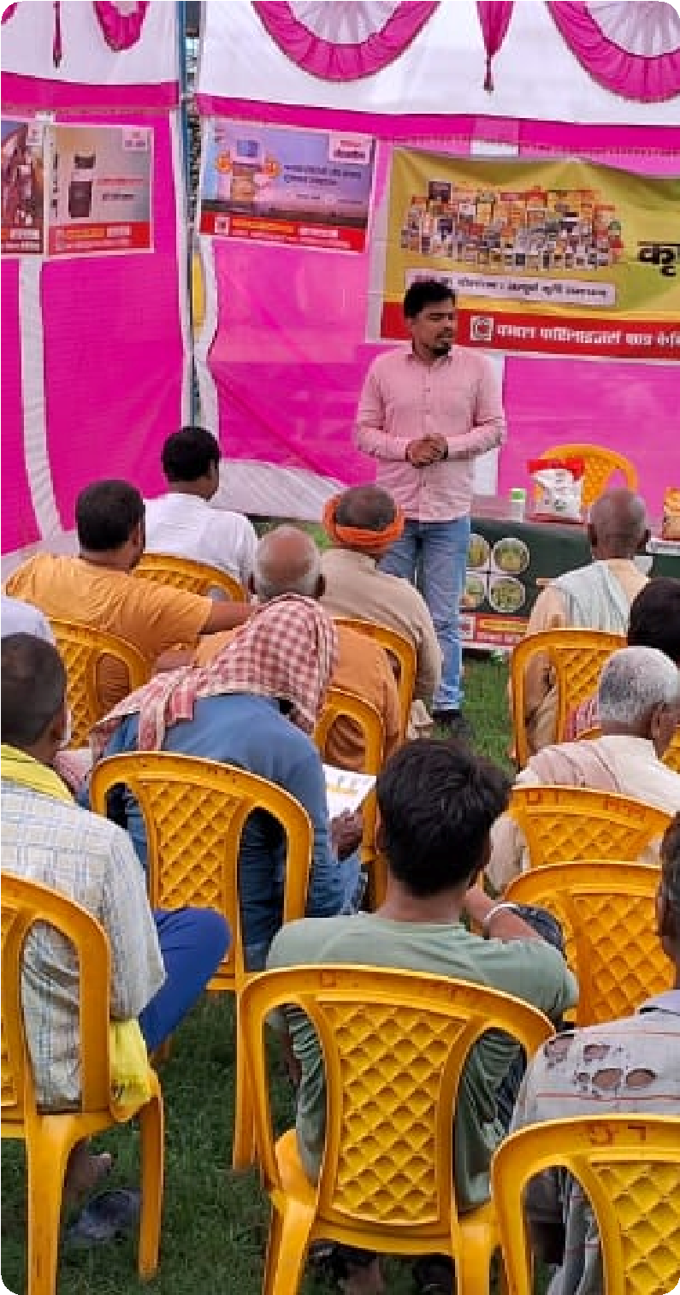

**Meeting**

**Organized**

**By**

**:**

Mr. Arunish kumar, UKS Rohtash

**Village**

**:**

Harnachiti

**District**

**:**

Rohtash

**Focus**

**Crops**

**:**

Paddy

,

Vegetables

**Participants**

**Attended**

**By**

**:**

DMM

-

Ashish

pratap

singh

**Dealer**

**:**

**Name**

**:**

Bihar

khad

bhandar

**Proprietor**

**:**

Khurshid

Alam

**Location**

**:**

tilouthu

**Attendance**

**:**

40+

farmers

**Topics**

**Discussed**

1

.

Company

profile

and

vision

.

2

.

S

2

H

Project

,

services

,

and

products

:

**CPC**

**:**

Azole

Agros

Pevota

,

Onvix

,

lexon

-

Etc

**SN**

**:**

Sulton

,

Superrhiza

,

Sulfino

Gold

,

etc

.

3

.

Importance

of

soil

testing

&

Bio

-

Fertilizers

.

4

.

Benefits

of

Superrhiza

in

all

crops

.

5

.

Addressed

farmer

queries

with

solutions

.

.

6

Encouraged

download

of

Uttam

Krishi

Mitra

app

.

7

.

Explained

app

features

and

benefits

for

daily

farming

.

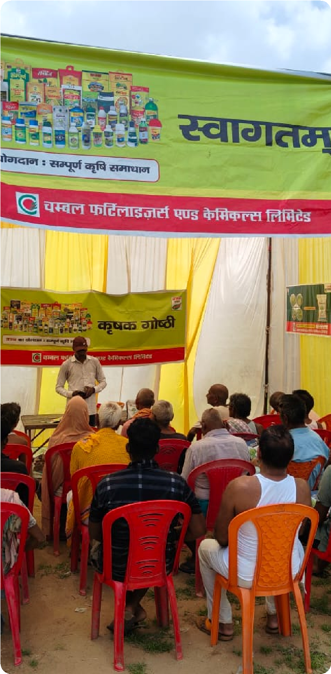

**Meeting**

**Organized**

**By**

**:**

Mr. Arunish kumar, UKS Rohtash

**Village**

**:**

Sewahi

**District**

**:**

Rohtash

**Focus**

**Crops**

**:**

Paddy

,

Vegetables

**Participants**

**Attended**

**By**

**:**

DMM

-

Ashish

pratap

singh

**Dealer**

**:**

**Name**

**:**

Bihar

khad

bhandar

**Proprietor**

**:**

dharmendar

khad

bhandar

**Location**

**:**

sewahhi

**Attendance**

**:**

50

farmers

**Topics**

**Discussed**

1

.

Company

profile

and

vision

.

2

.

S

2

H

Project

,

services

,

and

products

:

**CPC**

**:**

Azole

Agros

Pevota

,

Onvix

,

lexon

-

Etc

**SN**

**:**

Sulton

,

Superrhiza

,

Sulfino

Gold

,

etc

.

3

.

Importance

of

soil

testing

&

Bio

-

Fertilizers

.

4

.

Benefits

of

Superrhiza

in

all

crops

.

5

.

Addressed

farmer

queries

with

solutions

.

6

.

Encouraged

download

of

Uttam

Krishi

Mitra

app

.

7

.

Explained

app

features

and

benefits

for

daily

farming

.

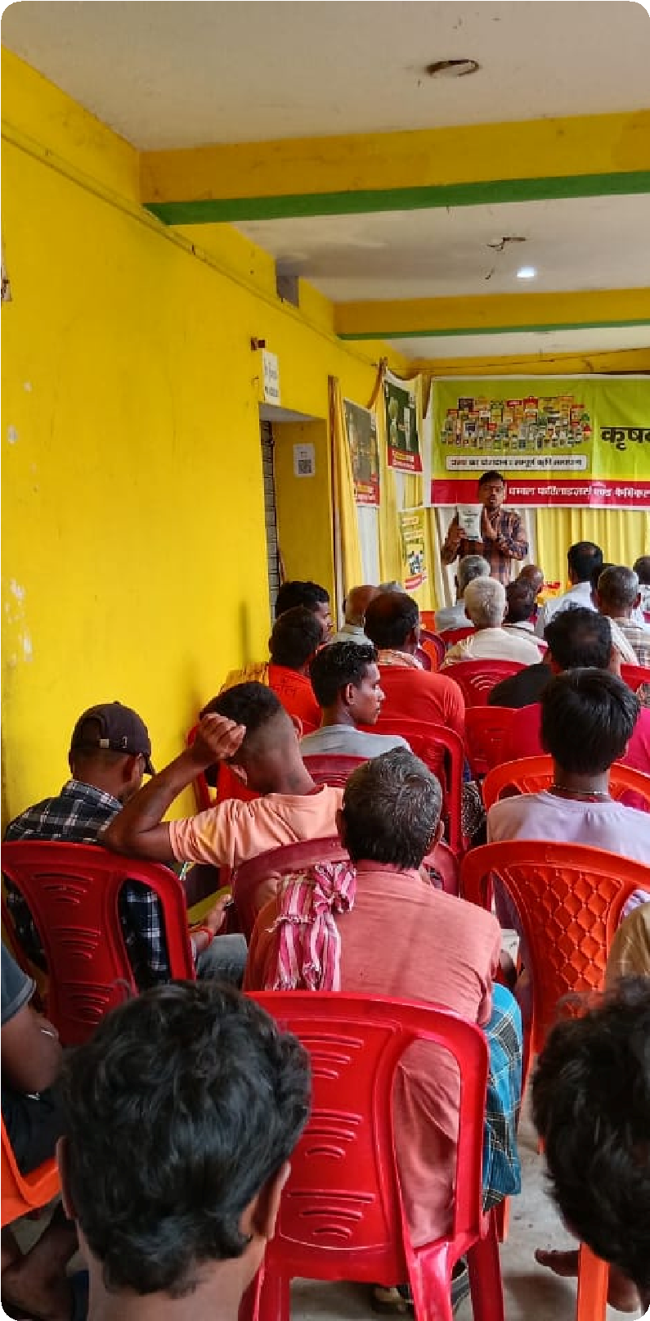

**Meeting**

**Organized**

**By**

**:**

Mr. Arunish kumar, UKS Rohtash

**Village**

**:**

Tenduni

**District**

**:**

Rohtash

**Focus**

**Crops**

**:**

Paddy

**Participants**

**Addressed**

**By**

**:**

Mr

.

Ashish

Pratap

singh

(

AMM

Sasaram

)

**Dealer**

**:**

**Name**

**:**

kumar

beej

bhandar

**Proprietor**

**:**

Bholenath

**Location**

**:**

dhaudandh

**Mobile**

**:**

8210110483

**Attendance**

**:**

50+

farmers

**Topics**

**Discussed**

1

.

Company

profile

and

vision

.

2

.

S

2

H

Project

,

services

,

and

products

:

**CPC**

**:**

Fillip

,

Mozo

,

Onvix

,

Lexon

,

Azole

,

etc

.

**SN**

**:**

Sulton

,

Superrhiza

,

Sulfino

Gold

,

etc

.

3

.

Importance

of

soil

testing

&

Bio

-

Fertilizers

.

4

.

Importance

of

Superrhiza

in

Paddy

crop

.

.

5

Addressed

general

and

technical

queries

with

solutions

.

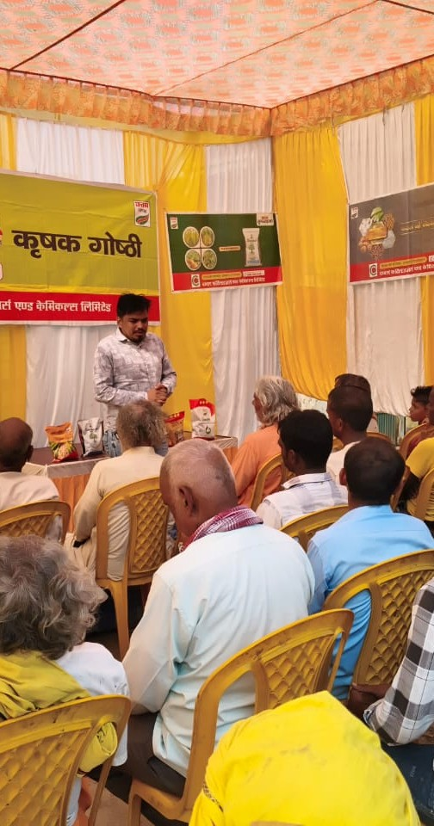

**Meeting**

**Organized**

**By**

**:**

Mr. Arunish kumar, UKS Rohtash

**Village**

**:**

Chanka

**District**

**:**

Rohtash

**Focus**

**Crops**

**:**

Paddy

**Participants**

**Addressed**

**By**

**:**

Mr

.

Ashish

Pratap

singh

(

AMM

Sasaram

)

**Dealer**

**:**

**Name**

**:**

jay

bajrang

enterprises

**Proprietor**

**:**

Ajit

singh

**Location**

**:**

jakhini

mod

**Mobile**

**:**

79035 17957

**Attendance**

**:**

50+

farmers

**Topics**

**Discussed**

1

.

Company

profile

and

vision

.

.

2

S

2

H

Project

,

services

,

and

products

:

**CPC**

**:**

Fillip

,

Mozo

,

Onvix

,

Lexon

,

Azole

,

etc

.

**SN**

**:**

Sulton

,

Superrhiza

,

Sulfino

Gold

,

etc

.

3

.

Importance

of

soil

testing

&

Bio

-

Fertilizers

.

.

4

Importance

of

Superrhiza

in

Paddy

crop

.

5

.

Addressed

general

and

technical

queries

with

solutions

.

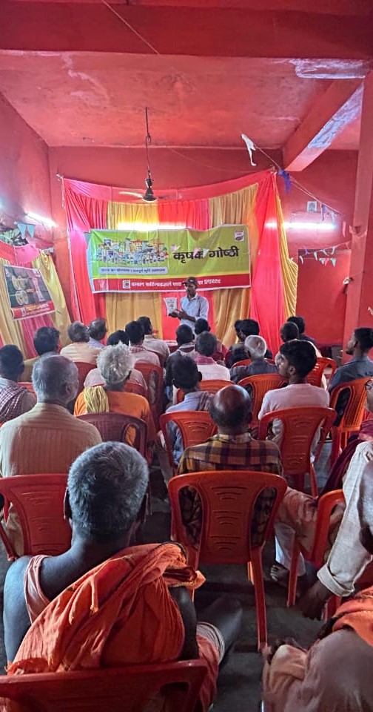

**Meeting**

**Organized**

**By**

**:**

Mr. Arunish kumar, UKS Rohtash

# 🌾 Crop Seminar Report 🌾

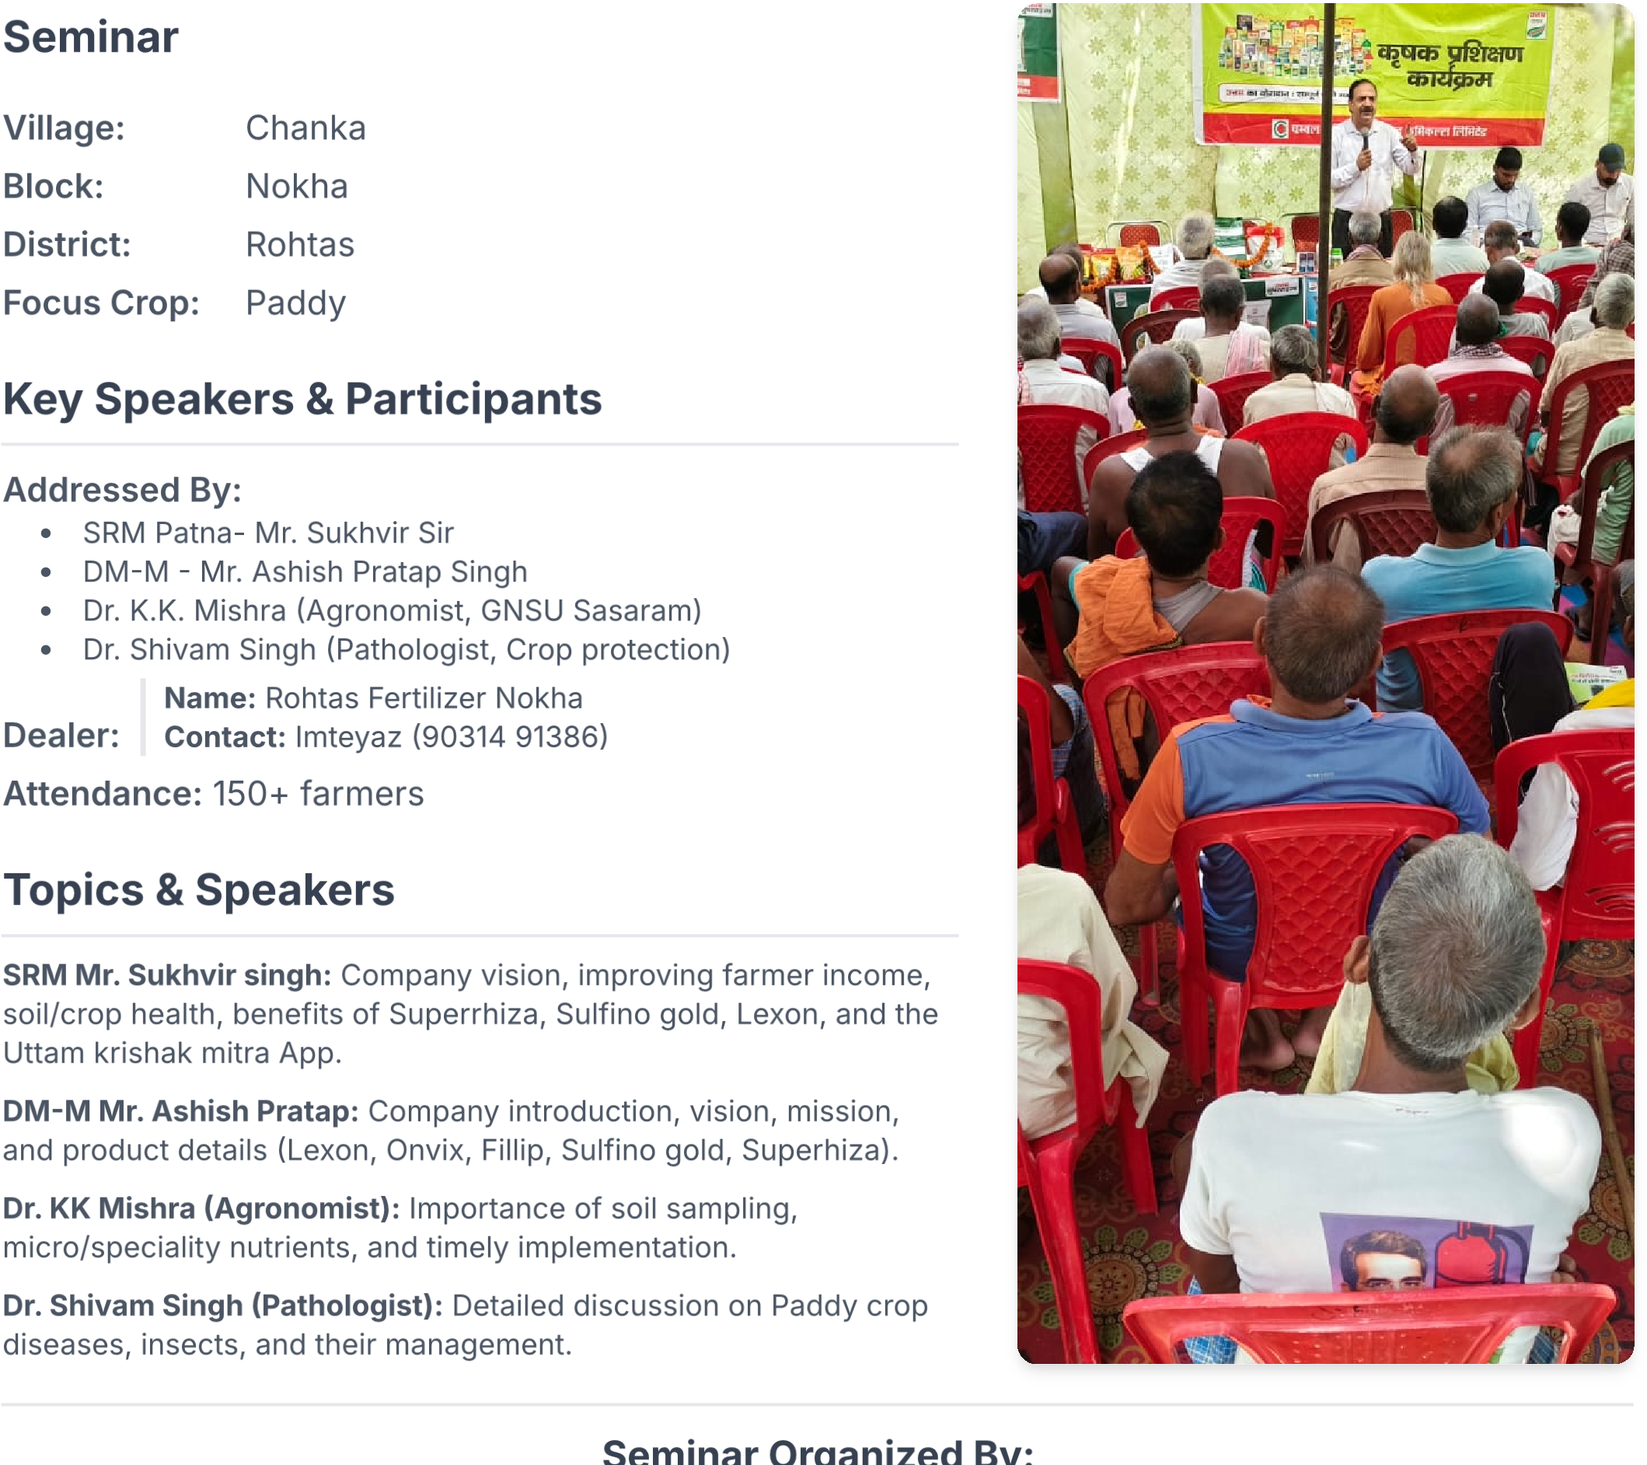

Regards, Aashish Pratap, DM-M Sasaram